

**Hues of Holi celebrations at Agastya Academy**

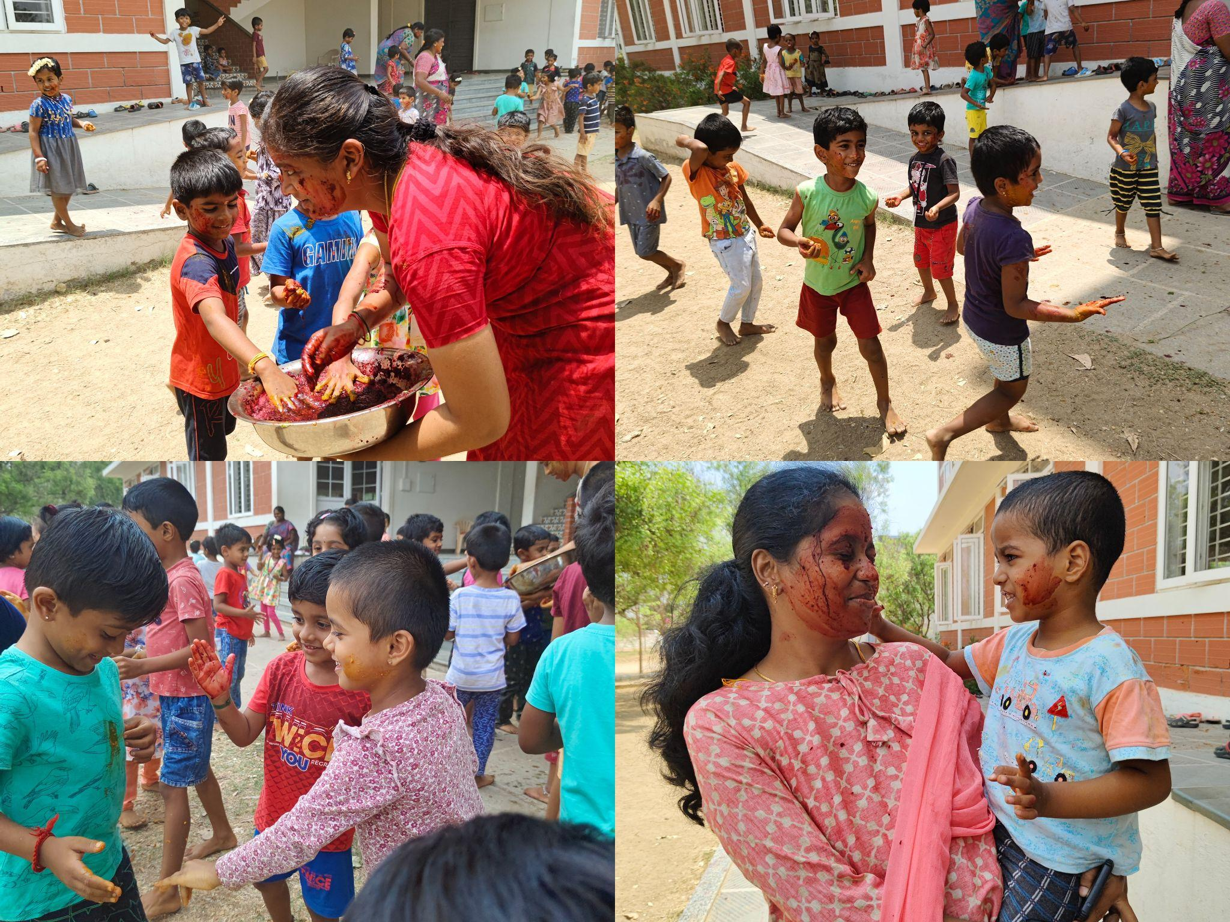

Holi, the festival of colors, is a time-honored tradition celebrated with zest and zeal across India. At Agastya Academy Kindergarten, we celebrated Holi in a manner that aligns with our values of sustainability and eco-friendliness. This year's Holi celebrations showcased our true commitment to encouraging a deep appreciation for nature while creating joyful memories for our children.

[Click for more details…..](https://www.agastyaacademy.edu.in/post/hues-of-holi-celebrations-at-agastya-academy-1)